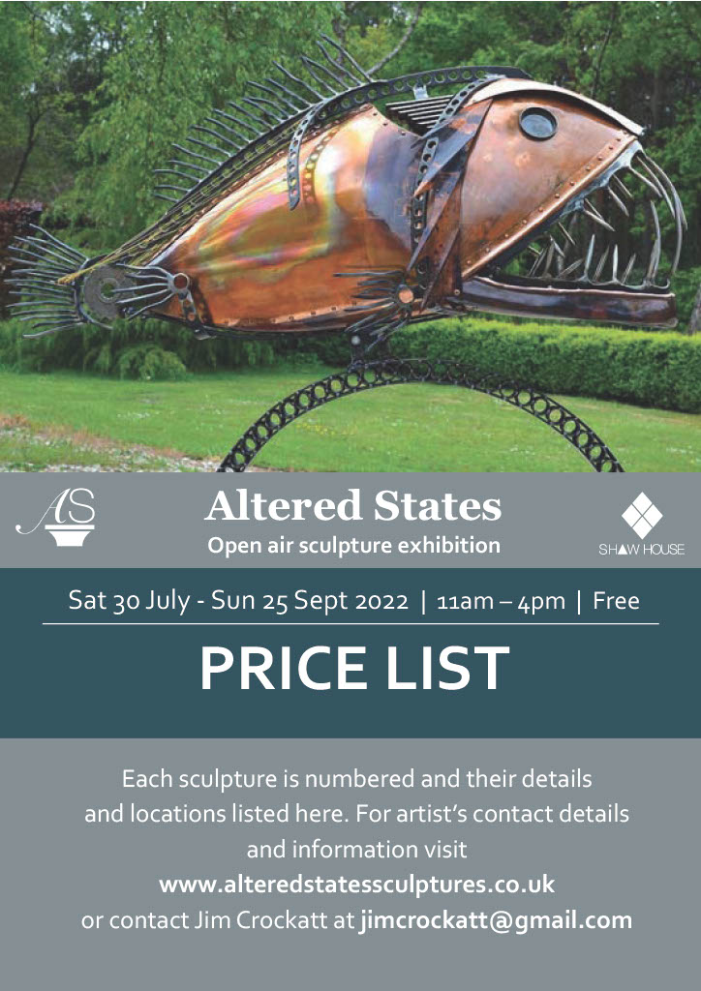

|  |  |  |  |  |  |
| --- | --- | --- | --- | --- | --- |
| **No.** | **Artist** | **Title** | **Medium** | **Price** | **Editions** |
| 1 | Steve Bicknell | Handstand Man | Steel & Concrete | £2,500 |  |
| 2 | Steve Bicknell | The Ovary | Steel & Concrete | £2,800 |  |
| 3 | Steve Bicknell | Spores | Steel & Concrete | £3,500 |  |
| 4 | Steve Bicknell | Dancing Man | Steel & Concrete | £3,000 |  |
| 5 | Diana Barraclough | Rock Pool | Ceramics | £450 | 2/20 |
| 6 | Diana Barraclough | Beach Boulder 1 | Ceramics | £450 | 1/20 |
| 7 | Diana Barraclough | Beach Boulder 2 | Ceramics | £390 |  |
| 8 | Diana Barraclough | Flow | Ceramics | £800 | 2/20 |
| 9 | Diana Barraclough | Ebb & Flow | Ceramics | £900 |  |
| 10 | Gary Boulton | Sky Dance | Stainless &Mild Steel | £6,800 |  |
| 11 | Diccon Dadey | Landed Owl | Mild Steel | £770 |  |
| 12 | Diccon Dadey | Landing Owl | Mild Steel | £770 |  |
| 13 | James Dunnett | Seated Figure | Bath stone on slate | £2,300 |  |
| 14 | James Dunnett | Reclining Figure | Bath stone on slate | £1,500 |  |
| 15 | Ted Edley | Still Handsome | Copper &Steel | £3,800 | 1/20 |
| 16 | Robert Fitzmaurice | Deity | Bronze | £4,200 | 1/12 |
| 17 | Paul Harvey | Barn Owl Landing | Cast White Marble | £1,450 | 2/20 |
| 18 | Paul Harvey | Peregrine | Pewter Finish | £1,500 | 1/20 |
| 19 | Paul Harvey | Little Owl | Mixed Metal Resin | £295 | 2/22/20 |
| 20 | Paul Harvey | Kestrel Landed | Mixed Metal Resin | £445 |  |
| 21 | Paul Harvey | Wren | Pewter Finish | £245 |  |
| 22 | [Sophie](http://www.alteredstatessculptures.co.uk/sculptorsGoldie.php?artid=8) Marsham | Copper Tin Blue Glass | Found Objects, Resin & Stainless Steel | £720 |  |
| 23 | [Sophie](http://www.alteredstatessculptures.co.uk/sculptorsGoldie.php?artid=8) Marsham | Brass & Tin Flower | Found Objects, Resin & Stainless Steel | £720 |  |
| 24 | [Sophie](http://www.alteredstatessculptures.co.uk/sculptorsGoldie.php?artid=8) Marsham | Brass Sun | Found Objects, Resin & Stainless Steel | £600 |  |
| 25 | Sophie Marsham | Fairground Flower 1 | |  |  | | --- | --- | | Found Objects, Resin & Stainless Steel | £600 | | £600 |  |
| 26 | [Sophie](http://www.alteredstatessculptures.co.uk/sculptorsGoldie.php?artid=8) Marsham | Fairground Flower 2 | Found Objects, Resin & Stainless Steel | £600 |  |
| 27 | [Sophie](http://www.alteredstatessculptures.co.uk/sculptorsGoldie.php?artid=8) Marsham | Copper Brass Sun | Found Objects, Resin & Stainless Steel | £1,200 |  |
| 28 | Sophie Marsham | 9 Painted Flowers | Steel | £350 |  |
| 29 | Emmanuel Okoro | Vessel | Bronze Resin | £2,500 | 3/12 |
| 30 | Emmanuel Okoro | Tired Feet | Bronze Resin | £2,000 | 1/12 |
| 31 | [Emmanuel](http://www.alteredstatessculptures.co.uk/sculptorsingleby.php?artid=12) Okoro | Rose | Bronze Resin | £2,000 | 1/12 |
| 32 | Carol Orwin | Hare Repose | Bronze/Iron Resin | £600 | Plinth NFS |
| 33 | Carol Orwin | Sit & Stare | Bronze Resin | £600 | Plinth NFS |
| 34 | Carol Orwin | We Are Siamese | Marble Resin | £400 | Plinth £50.0 |
| 35 | Paul Pibworth | Jacob | Mild & Stainless Steel | £7,000 |  |
| 36 | Paul Pibworth | The Cross | Steel Cut & Clasp Nails | £11000 |  |
| 37 | Jane Rickards | Aurochs | Bronze | £12,750 | 2/5 |
| 38 | Jane Rickards | White Eagle | Fibreglass & resin | £3750 |  |
| 39 | [Kate](http://www.alteredstatessculptures.co.uk/sculptorsmarlow.php?artid=14) Robinson | Awakening Earth | Cement Fondue, brass, paint & wood | £2,500 |  |
| 40 | [Kate](http://www.alteredstatessculptures.co.uk/sculptorsmarlow.php?artid=14) Robinson | Awakening Rising | Cement Fondue, glass mosaic, paint & wood | £4,800 |  |
| 41 | Kate Robinson | Awakening Joining | Bronze Resin | £5,600 |  |
| 42 | Helen Sinclair | The Skellig Boatman | Stone-Resin | £4,500 | 4/15 |
| 43 | [Helen](http://www.alteredstatessculptures.co.uk/sculptorsMartin.php?artid=15) Sinclair | All the flowers from the Mountain | Stone-Resin | £5,250 | 1/15 |
| 44 | [Helen](http://www.alteredstatessculptures.co.uk/sculptorsMartin.php?artid=15) Sinclair | Looking Good | Stone-Resin | £5,500 | 1/15 |
| 45 | [Jilly](http://www.alteredstatessculptures.co.uk/sculptorsMartin.php?artid=15) Sutton | Flight of Fancy | Stonecast | £3,500 | 2/20 |
| 46 | [Jilly](http://www.alteredstatessculptures.co.uk/sculptorsmenac.php?artid=16) Sutton | Midsummer Night’s Dream | Bronze on Slate | £4,800 | 1/20 |
| 47 | [Colin](http://www.alteredstatessculptures.co.uk/sculptorsmenac.php?artid=16) Underhay | Horns | Oak | £1100 |  |
| 48 | [Colin](http://www.alteredstatessculptures.co.uk/sculptorsmenac.php?artid=16) Underhay | Legs | Oak | £1000 |  |
| 49 | [Adam](http://www.alteredstatessculptures.co.uk/sculptorsmoreton.php?artid=17) Warwick-Hall | Forked-Tailed Devil | Bronze | £1,800 | 2/12 |
| 50 | [Adam](http://www.alteredstatessculptures.co.uk/sculptorsmoreton.php?artid=17) Warwick-Hall | A Clipping of Wings | Bronze | £1,950 | 4/12 |
| 51 | [Adam](http://www.alteredstatessculptures.co.uk/sculptorsmoreton.php?artid=17) Warwick-Hall | Sea Harrier Hawk | Bronze | £1,500 | 2/12 |
| 52 | [Teresa](http://www.alteredstatessculptures.co.uk/sculptorsoconnor.php?artid=18) Wells | Narcissus | Bronze/Steel | £10,420 | 9/12 |
| 53 | [Teresa](http://www.alteredstatessculptures.co.uk/sculptorspalmer.php?artid=19) Wells | Loki | Bronze/Steel | £9,891 | 1/12 |
| 54 | [Joanne](http://www.alteredstatessculptures.co.uk/sculptorspalmer.php?artid=19) Risely | Winged Seed | Cor-ten Steel | £3,000 |  |
| 55 | [Joanne](http://www.alteredstatessculptures.co.uk/sculptorsraescott.php?artid=20) Risely | Embryo | Cor-ten Steel | £2,800 |  |
| 56 | Jim Crockatt | Fidelity | Oak | £600 |  |
| 57 | [Jim](http://www.alteredstatessculptures.co.uk/sculptorsshilling.php?artid=22) Crockatt | Pencils | Larch | £60 | 20 |
| 58 | [Jim](http://www.alteredstatessculptures.co.uk/sculptorsshilling.php?artid=22) Crockatt | Peg | Oak | £1,000 |  |
| 59 | [Jim](http://www.alteredstatessculptures.co.uk/sculptorsshilling.php?artid=22) Crockatt | Ripple | Oak | £800 |  |
| 60 | [Jim](http://www.alteredstatessculptures.co.uk/sculptorsshilling.php?artid=22) Crockatt | Talking Heads | Oak | £900 |  |
| 61 | [Jim](http://www.alteredstatessculptures.co.uk/sculptorsshilling.php?artid=22) Crockatt | Citadel | Oak | £600 |  |
| 62 | Jim Crockatt | Fertility | Oak | £300 |  |
| 63 | Jim Crockatt | Ferocity | Oak | £500 |  |
| 64 | Jim Crockatt | Obelisk | Oak | £700 |  |

Steve Bicknell

‘Spores’ This piece is based on a fallen mushroom and contains Pink Oyster Mushroom Spores buried into the concrete on the inside of the cap!  The concept is that nature is all enduring where humanity is striving hard to exist on our planet. This art sculpture will continue to be a feature in my future exhibition ‘Return to the Earth’  I would very welcome a purchaser being able to place the sculpture amongst nature where it can gradually weather down over the next several thousand years.

‘The Ovary’ This art sculpture is based on a pumpkin and contains pumpkin seeds carefully preserved within the piece. Over the next thousand years the sculpture will gradually open up through deterioration and there is a strong likelihood that the seeds could still germinate. I would very much welcome a purchaser to place this piece in a natural setting and it will always be featured in my long standing project ‘Return to the Earth’ where I am planning to put on a public exhibition during 2025/2026

Kate Robinson

The sculptures tell a story about awakening from the earth, representing joy, health and hope.

Visitors are advised to treat the sculptures with the respect that they deserve. Thank you and enjoy the show

It is an organic show so far, as sculptures will be added to it over the duration of the show.

So come and come again!

Jim Crockatt Curator.

